**Mobile-based Pathology and Radiology Services for Rural Areas of Pakistan**

**ZOHAIB AHMED**

**AREEBA SHAFAAT**

**SYED MUHAMMAD AHMED KHALID**

**A project report submitted in partial fulfilment of the**

**Requirements for the award of the degree of**

**Bachelor of Computer Science (Honours)**

**Department of Computer Science**

**Bahria University, Karachi Campus**

**July 2019**

DECLARATION

We hereby declare that this project report is based on our original work except for citations and quotations which have been duly acknowledged. We also declare that it has not been previously and concurrently submitted for any other degree or award at Bahria University or other institutions.

Signature : _________________________

Name : Zohaib Ahmed_ ______

Reg No. : 43743 ______________

Signature : _________________________

Name : Areeba Shafaat_ ______

Reg No. : 43716 ______________

Signature : _________________________

Name : Syed Muhammad Ahmed Khalid

Reg No. : 43712 ______________

Date : 3-July-2019__________

APPROVAL FOR SUBMISSION

We certify that this project report entitled “**MOBILE BASED APPLICATION OF RADIOLOGY AND PATHOLOGY IN RURAL AREAS OF PAKISTAN”** was prepared by **ZOHAIB AHMED, AREEBA SHAFAAT, and SYED MUHAMMAD AHMED KHALID** has met the required standard for submission in partial fulfilment of the requirements for the award of Bachelor of Computer Science (Honours) at Bahria University.

Approved by, Dr. Ghulam Muhammad Shaikh

Signature : _________________________

Supervisor: Dr. Ghulam Muhammad Shaikh

Date : 3-July-2019__________

The copyright of this report belongs to the author under the terms of the copyright Ordinance 1962 as qualified by Intellectual Property Policy of Bahria University. Due acknowledgement shall always be made of the use of any material contained in, or derived from, this report.

© 2019, Zohaib Ahmed, Areeba Shafaat, Syed Muhammad Ahmed Khalid. All right reserved.

ACKNOWLEDGEMENTS

We would like to thank everyone who had contributed to the successful completion of this project. We would like to express my gratitude to my research supervisor, Dr Ghulam Muhammad Shaikh for his invaluable advice, guidance and his enormous patience throughout the development of the research.

In addition, we would also like to express my gratitude to our loving parent and friends who had helped and given me encouragement.

**MOBILE BASED APPLICATION OF RADIOLOGY AND PATHOLOGY IN RURAL AREAS OF PAKISTAN**

ABSTRACT

The objective of this project is to develop an android application to provide an easy solution for users to submit digital pathology images to pathology experts for consultation. Smartphones have great potential to support telepathology because they are portable, provide ubiquitous internet connectivity, contain excellent digital cameras, and can be easily attached to a microscope. Smart phone applications (apps) for radiologists are on the rise. Not only do they assist the radiologist in reference to information but they can also aid in their day-to-day functioning too most notably through image viewing apps known as Digital Imaging and Communications in Medicine (DICOM) viewers. These kinds of apps signal a transition towards an increasingly mobile medical environment in what could be an exciting but cautious time for radiologists as these apps are not without their own concerns.

Telepathology allows the digital transmission of images for rapid access to pathology experts. Recent technologic advances in smartphones have allowed them to be used to acquire and transmit digital images of the glass slide, representing cost savings and efficiency gains over traditional forms of telepathology.

The aim of this study is to illustrate how smartphones and tablets can be used by diagnostic imaging professionals, radiographers and residents, and to introduce relevant applications that are available for their field.

TABLE OF CONTENTS

DECLARATION ii

APPROVAL FOR SUBMISSION iii

ACKNOWLEDGEMENTS v

ABSTRACT vi

TABLE OF CONTENTS vii

LIST OF TABLES ix

LIST OF FIGURES x

LIST OF SYMBOLS / ABBREVIATIONS xi

LIST OF APPENDICES xii

**CHAPTER**

1 INTRODUCTION 1

1.1 Background 1

1.1.1 Pathology 1

1.1.2 Radiology 2

1.1.3 Cloud Computing 3

1.2 Problem Statements 5

1.3 Aims and Objectives 5

1.4 Scope of Project 5

2 LITERATURE REVIEW 6

2.1 Introduction 6

2.2 Smartphones and Medical Services 6

2.3 Mobile Applications for Radiology 7

2.4 Tele-pathology 8

2.5 Cloud Computing 9

2.5.1 Mobile Cloud Computing 10

2.5.2 Cloud Services 11

3 DESIGN AND METHODOLOGY 13

3.1 Framework 13

3.2 Tools and Languages 14

3.3 Developing Lifecycle 14

3.4 Proposed Model Design 16

3.4.1 Method To Implement Application 17

3.4.2 Interface of Application 18

3.4.3 Login Phase 19

3.4.4 Registration Phase 20

3.4.5 Doctor's Home 21

REFERENCES 22

APPENDICES 24

LIST OF TABLES

**TABLE TITLE PAGE**

2.1 Display parameters of high-end laptop, the iphone, the ipad 4

LIST OF FIGURES

**FIGURE TITLE PAGE**

Figure 1.1: Pathology 1

Figure 1.2: Radiology Appearence 3

Figure 1.3: Cloud Representation 4

Figure 2.1: Telepathology Model 9

Figure 2.2: Cloud Model 10

Figure 2.3: Mcc 11

Figure 2.4: Cloud Services 12

Figure 3.1: Relatinship among big data and mcc 14

Figure 3.2: Life cycle 15

Figure 3.3: Proposed Model 16

Figure 3.4: Splash Screen 18

Figure 3.5: Login phase 19

Figure 3.6: Registration phase 20

Figure 3.7: Doctors home screen 21

LIST OF SYMBOLS / ABBREVIATIONS

DICOM Digital Imaging and Communications in Medicine

CT Computed tomography

PET Positron Emission Tomography

MRI Magnetic Resonance Imaging

SAAS Software as a Service

PAAS Platform as a Service

IAAS Infrastructure as a Service

MCC Mobile Cloud Computing

LIST OF APPENDICES

**APPENDIX TITLE PAGE**

A Gantt Chart 24

## INTRODUCTION

### Background

This proposed project is basically designed for the rural areas of Pakistan to improve healthcare. We will design android based mobile phone application which can accessed by anyone specially those people of rural areas who cannot travel on daily basis. Its mobile cloud computing based psychological and nervous system disorder disease detection methodology. Android mobile app will gather the Patient’s video, voice and images. The gathered data will be uploaded on profile where the patients can get free consultancy from general physicians of all over the country.

**1.1.1 Pathology**

Pathology is the study of the causes and effects of disease or injury. The word pathology also refers to the study of disease in general, incorporating a wide range of bioscience research fields and medical practices. However, when used in the context of modern medical treatment, the term is often used in a more narrow fashion to refer to processes and tests which fall within the contemporary medical field of "general pathology," an area which includes a number of distinct but inter-related medical specialties that diagnose disease, mostly through analysis of tissue, cell, and body fluid samples.

Digital pathology is an image-based information environment which is enabled by computer technology that allows for the management of information generated from a digital slide. Digital pathology is enabled in part by virtual microscopy, which is the practice of converting glass slides into digital slides that can be viewed, managed, shared and analysed on a computer monitor

With the advent of Whole-Slide Imaging, the field of digital pathology has exploded and is currently regarded as one of the most promising avenues of diagnostic medicine in order to achieve even better, faster and cheaper diagnosis, prognosis and prediction of cancer and other important diseases.

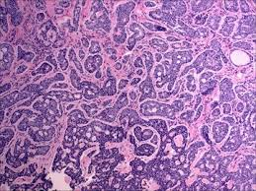 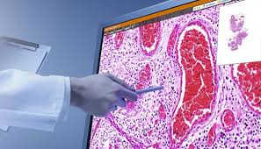  
Figure 1.1

**1.1.2. Radiology**

Radiology is the medical specialty that uses medical imaging to diagnose and treat diseases within the human body. A variety of imaging techniques such as X-ray radiography, ultrasound, computed tomography (CT), nuclear medicine including positron emission tomography (PET), and magnetic resonance imaging (MRI) are used to diagnose or treat diseases. Interventional radiology is the performance of usually minimally invasive medical procedures with the guidance of imaging technologies such as X-ray radiography, ultrasound, computed tomography (CT), nuclear medicine including positron emission tomography (PET), and magnetic resonance imaging (MRI).

Radiology is the study of high-energy radiation used to examine and diagnose internal structures. The process of using radiology to make images is called [radiography](https://www.sciencedirect.com/topics/medicine-and-dentistry/radiography). Radiology in forensic anthropology is useful for documentation as well as detection and diagnostic applications and may include traditional two-dimensional radiography or [computed tomography](https://www.sciencedirect.com/topics/medicine-and-dentistry/computer-assisted-tomography) (CT). It can be used to produce a record of the condition of the remains at the time of examination, detect the presence of foreign material such as a bullet, and visualize internal skeletal structures that are not visible to the naked eye such as [paranasal sinuses](https://www.sciencedirect.com/topics/medicine-and-dentistry/paranasal-sinuses) or developing [dentition](https://www.sciencedirect.com/topics/medicine-and-dentistry/dentition). It can also be used to diagnose conditions such as antemortem fractures or pathological conditions, or to see the placement of surgical implants.

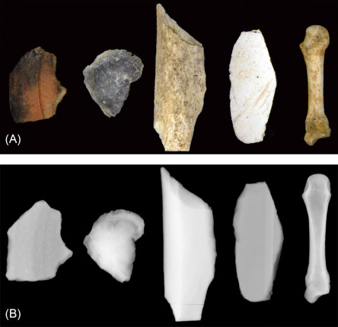

Fig. 1.2. Radiographic appearance of various materials—left to right: ceramic, fossilized shell, non-human long bone fragment, plastic, human metacarpal.

**1.1.3. Cloud Computing**

The expression “cloud computing” refers to the access of computing resources through the Internet for purposes of data storage, aggregation, synthesis, a retrieval, together with the capacity to act on the data with computational algorithms and software packages. Cloud computing is available on-demand and provides flexible and scalable computing resources from remote locations. It is particularly useful in research applications involving multiple investigators at different institutions, and in large-scale data processing applications such as

those in clinical medicine. It may well become a major resource in efforts to identify surrogate measures to clinical trials for evaluation of new drugs and devices in biomedicine. A number of cloud-computing resources are available for use in research applications.

Rather than owning their own computing infrastructure or data centres, companies can rent access to anything from applications to storage from a cloud service provider.

One benefit of using cloud computing services is that firms can avoid the upfront cost and complexity of owning and maintaining their own IT infrastructure, and instead simply pay for what they use, when they use it.

Cloud computing services cover a vast range of options now, from the basics of storage, networking, and processing power through to natural language processing and artificial intelligence as well as standard office applications. Pretty much any service that doesn't physically close to the computer hardware that you are using can now be delivered via the cloud.

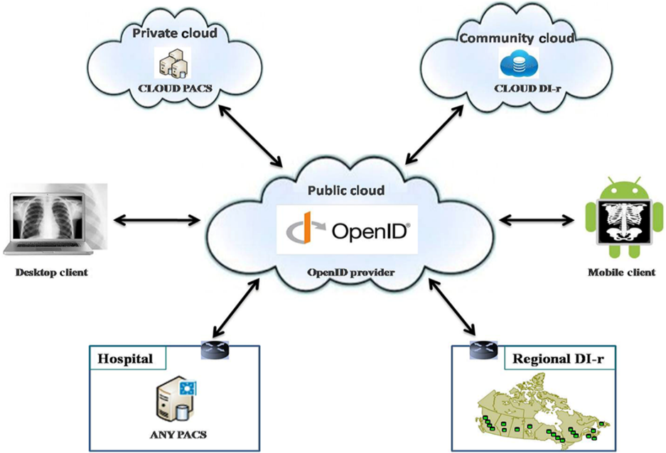

Figure 1.3. Cloud Representation

### Problem Statements

In Rural areas of Pakistan, provide the state-of-the-art medical facilities on time is a very challenging task. A place where a general physician (MBBS doctor) is not available to facilitate the good medical treatment, how can we imagine the existence of a physiologist of neurologist?

### Aims and Objectives

Our objective of this proposed methodology is:

1. To provide diagnosis of psychological and nervous system disorder disease in rural areas of Pakistan without/minimum specialist’s intervention.

2. To design such mobile applications which would mainly target hospitals, clinical labs, reference labs and consulting pathologists.

### Scope of Project

The proposed android mobile application can be beneficial for rural areas of Pakistan. Its simple methodology can be used by everyone. Patients just have to upload their reports, video, audio or an image and the data will be uploaded on patient’s profile. This application can used in hospitals, homes, work places, educational institutes, private clinics and so on. If people of any area are not able to use application or they do not have smart phones then they can make their profile through local dispensary. Doctors will help people in their free slots and their free slots will be mentioned on their profile. If anyone wants to consult on emergency basis they will be treat on priority.

## LITERATURE REVIEW

### Introduction

In spite of a steady improvement in the healthcare sector over the years, the condition of healthcare in Pakistan and much of the developing world is still far from satisfactory. Universal healthcare is still a dream even in the greater part of the developed world. One of the reasons for this lag is the fact that health sector in much of the developing and under-developed world suffers from inadequate funds that fail to even fulfil the most basic needs of the public.

Most of the population in rural areas, about 65% of the total population in Pakistan does not have access to any sort of healthcare. Moreover, the hospitals in adjoining semi-urban and urban areas lack staff and equipment. Traveling outside of the community for all types of services is also inconvenient and more of that it’s difficult for a patient to travel 60-90 minute to consult any good doctor or physician.

 In earlier projects to bring improvement in the healthcare sector one project called “Jaroka Tele-Healthcare System (JTHS)”, utilizes the mobile phone platform to provide healthcare services in rural areas of Mardan. It provide SMS/MMS based services to register patients, report symptoms, acquire prescriptions and connect patients to the network of specialists.

This proposed project is basically designed for the rural areas of Pakistan to improve healthcare. We will design android based mobile phone application which can accessed by anyone specially those people of rural areas who cannot travel on daily basis. Its mobile cloud computing based psychological and nervous system disorder

disease detection methodology. Android mobile app will gather the Patient’s video, voice and images. The gathered data will be uploaded on profile where the patients can get free consultancy from general physicians of all over the country.

**2.2 Smartphones and Medical Services**

The digital pathology market has been flooded with recent technological advances developed in smartphones and other electronic devices. This has been used to acquire and transmit digital images of the glass slide, indicative of cost savings and productivity gains over traditional forms.

Medical applications on smartphones and other electronic devices are changing the face and user perspective towards medicine. The smartphone utility has also presented a new opportunity for digital pathology consultation in rural and other developing regions. Mobile applications designed for digital pathology serve as a platform as a management system for digital slide images. Such applications are designed to target the clinical workflow being managed by users including pathologists.

Mobile applications revolving around digital pathology would seamlessly integrate digital pathology into the standard laboratory workflow. It would allow uploading pathology images and creating a hierarchy of cases consisting of multiple digital slides, along with relevant metadata, case history and specimen description to happen easily. With advancements in digital pathology, additional features such as analysis, interpretation of slide images and generation of diagnostic reports may become widely used. These applications would provide users access to the lab anytime and empower the pathologist to collaborate and consult with other experts, globally in real-time.

**2.3 Mobile Applications for Radiology**

# A search was performed on iTunes, Android Market, Blackberry App World, and Windows Phone Marketplace for mobile applications pertinent to the field of diagnostic imaging. The following t

# erms were applied for the search strategy: (1) radiology, (2) X-ray, (3) ultrasound, (4) MRI, (5) CT, (6) radiographer, (7) nuclear medicine. Two radiologists and one radiology resident reviewed the results. Our review was limited to english-language software. Additional applications were identified by reviewing the list of similar software provided in the description of each application. We downloaded and installed all applications that appeared relevant to an appropriate mobile phone or tablet device.

Table 2.1

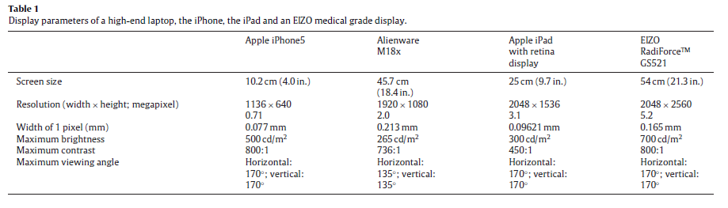

# We identified and reviewed a total of 102 applications. We ruled out 1 non-English application and 20 other applications that were created for entertainment purposes. Thus our final list includes 81 applications in the following five categories: diagnostic reading, decision support applications, medical books, interactive encyclopaedias, and journal reading programs.

**2.4 Tele-pathology**

Telepathology allows the digital transmission of images for rapid access to pathology experts. Recent technologic advances in smartphones have allowed them to be used to acquire and transmit digital images of the glass slide, representing cost savings and efficiency gains over traditional forms of telepathology. We report our experience with developing an iPhone application (App - Pocket Pathologist) to facilitate rapid diagnostic pathology teleconsultation utilizing a smartphone.

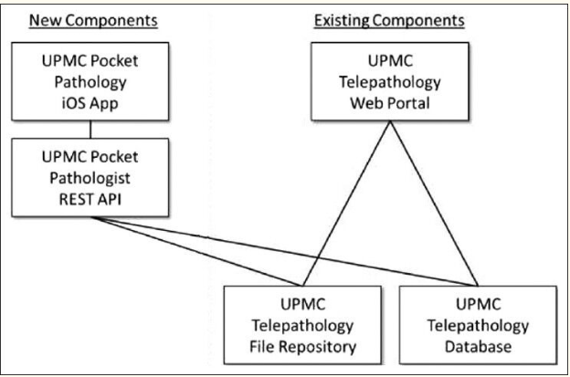

Figure 2.1 Model

### 2.5 Cloud Computing

Cloud computing is computing in which big clusters of remote servers are networked to sanction centralized data storage and online access to computer services or resources.

The cloud setup is deployed in four different deployment models as follows

1. Public Cloud: Services in public clouds are available to the all customer without pay.

1. Private cloud: Service in private clouds are available to only some customer which are sitting behind the firewall. These services are paid services.

1. Community cloud: A community cloud in computing is a collaborative effort in which infrastructure is shared between several organizations from a specific community with common concerns (security, compliance, jurisdiction, etc.), whether managed internally or by a third-party and hosted internally or

externally.

1. Hybrid Cloud: Services in hybrid cloud are the combination of public and private in which some services are freely available, and some are paid.

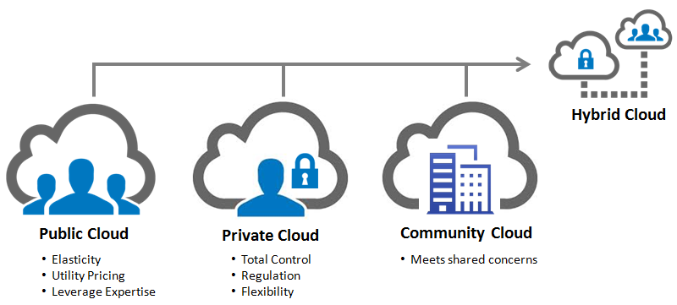

Figure 2.2 Cloud Models

#### 2.5.1 Mobile Cloud Computing

Another latest technology is cloud computing which allows access to the stored data from anywhere at any time, and can be utilized in different organizations or by individuals to improve efficiency and increase performance and decrease the cost and complexity. Moreover, integrating the mobile devices with cloud computing to utilize the unlimited service provided by the cloud through the mobile device results in what is known as Mobile Cloud Computing. The Cloud Computing relies on a set of network-connected resources shared to maximize their utilization resulting in reduced management and capital costs. Mobile Cloud Computing (MCC) is set to advantage many sectors including the cloud-healthcare systems. As an example, MCC healthcare system was built to capture and analyze real time biomedical signals (such as ECG and Blood pressure) from users in different locations. On the mobile device, a personalized healthcare application is installed and health data are being synchronized into the healthcare cloud computing service for storage and analysis.

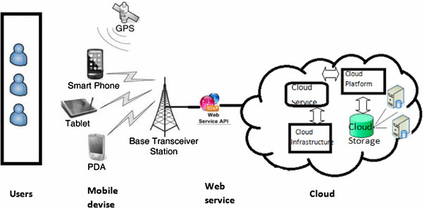

Figure 2.3 Mobile Cloud Computing

#### 2.5.2 Cloud Services

Cloud applications are provided as one of the three main service models as:

1. Software as a Service (SaaS): SaaS provides software to the user in the form of services which are hosted in a cloud.
2. Platform as a Service (PaaS): PaaS enables programming environments to access and utilize additional application building blocks. Such programming environments have a visible impact on the application architecture, such as constraints on which services the application can request from an OS.
3. Infrastructure as a Service (IaaS): IaaS enables customer to access the storage, other resources which are

Important for the user applications.

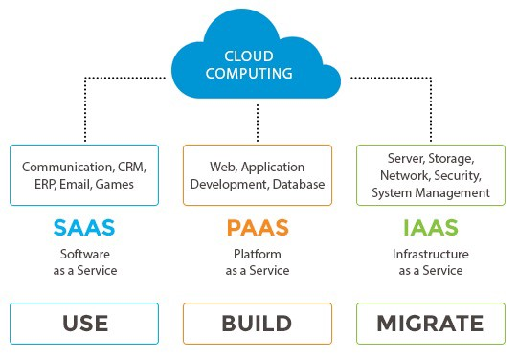

Figure 2.4 Cloud services

## DESIGN AND METHODOLOGY

### Framework

Using above emerging technologies and concepts, we are proposing a mobile cloud computing based psychological and nervous system disorder disease detection methodology.

Our proposed methodology will gather the Patient’s video (activities like walking, interaction with an object and face expressions), voice and images (e.g. MRI scans and X-rays).

Proposed methodology is very simple. Through Android mobile app, we will capture the patient’s video, audio and image data. The data will be send via streaming and Mobile cloud computing service to a Cloud analytical environment.

The data will be processed and psychological and nervous system disorder disease will be detected/classified using classical machine learning or deep learning algorithm.

The classified data will also be stored in our big data repository.

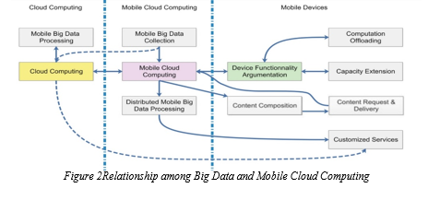

Figure 3.1 Relationship among big data and mcc

### Tools and Languages

**Tools**

* KERAS,
* TensorFlow,
* Google Cloud Machine Learning Engine,
* Microsoft Azure Machine Learning service,
* Apache Spark,
* Apache Kafka,
* MongoDB,
* Firebase Real-time Database,
* Android studio,
* Android Phones

### Developing Lifecycle

**Product Backlog:**  Product Backlog is simply a list of all things that needs to be done within the project. It replaces the traditional requirements specification artefacts. These items can have a technical nature or can be user-centric e.g. in the form of user stories.

**Sprint Planning: S**print planning is an event in the [Scrum](https://www.agilealliance.org/glossary/scrum/) framework where the team determines the product backlog items they will work on during that [sprint](https://www.agilealliance.org/glossary/iteration/) and discusses their initial plan for completing those [product backlog items](https://www.agilealliance.org/glossary/backlog/).

**Sprint Backlog:** The sprint backlog is a list of tasks identified by the Scrum team to be completed during the [Scrum](https://www.mountaingoatsoftware.com/agile/scrum) sprint. The sprint backlog is commonly maintained as a spreadsheet.

**Daily Scrum:** In [Scrum](https://www.mountaingoatsoftware.com/agile/scrum), on each day of a sprint, the team holds a daily scrum meeting called the daily scrum. Meetings are typically held in the same location and at the same time each day.

**Sprint Review:** In [Scrum](https://www.mountaingoatsoftware.com/agile/scrum), each sprint is required to deliver a potentially shippable product increment. This means that at the end of each sprint, the team has produced a coded, tested and usable piece of software. So at the end of each sprint, a sprint review meeting is held. During this meeting, the Scrum team shows what they accomplished during the sprint.

**Release Planning:** A very high-level plan for multiple Sprints is created during the Release planning. It is a guideline that reflects expectations about which features will be implemented and when they are completed.

**Release Product:** A product release is the process of launching a new product for a specific market or user base.

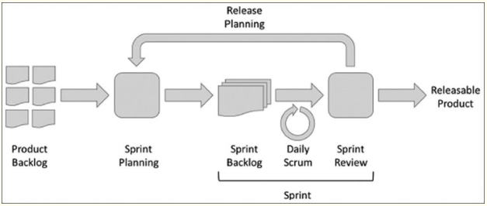

Figure.3.2 lifecycle

* 1. **Proposed Model Design**

**Figure 3.3 Proposed Model**

Dr Hazir Pathology and Radiology Rest API

Dr Hazir Pathology and Radiology Database

Dr Hazir Pathology and Radiology Android Mobile Application

**3.4.1 Method to Implement Application**

An Android App will be designed to provide a great user experience functioning as a standalone program. The development of the App required teamwork among pathologists and information technology professionals. The application will be developed over the course of four sprints. It will be critical to allow the android application to interface with the existing database structure currently used for the mobile. A secure Rest API was developed in. Net to allow the android application to communicate with the Microsoft SQL Server database. All data were encrypted in transit over https and at rest to eliminate the risk of electronic protected health information (ePHI) exposure. The intent was not to store ePHI on the smartphone device to mitigate privacy risk. Photographs could be stored encrypted within the application memory, but without any ePHI. We will complete development of an- android application called “Dr Hazir” to facilitate rapid second-opinion digital pathology consultations. The application will be launched as soon as completed and tested for capturing digital images using a smartphone camera from a light microscope, the submitting pathologist/institution was able to submit a full digital consultation request directly from an android phone with just a few taps on the smartphone.

#### 

#### Interface of Application

**3.4.1.1 Splash Screen**

A welcome screen when the application opens.

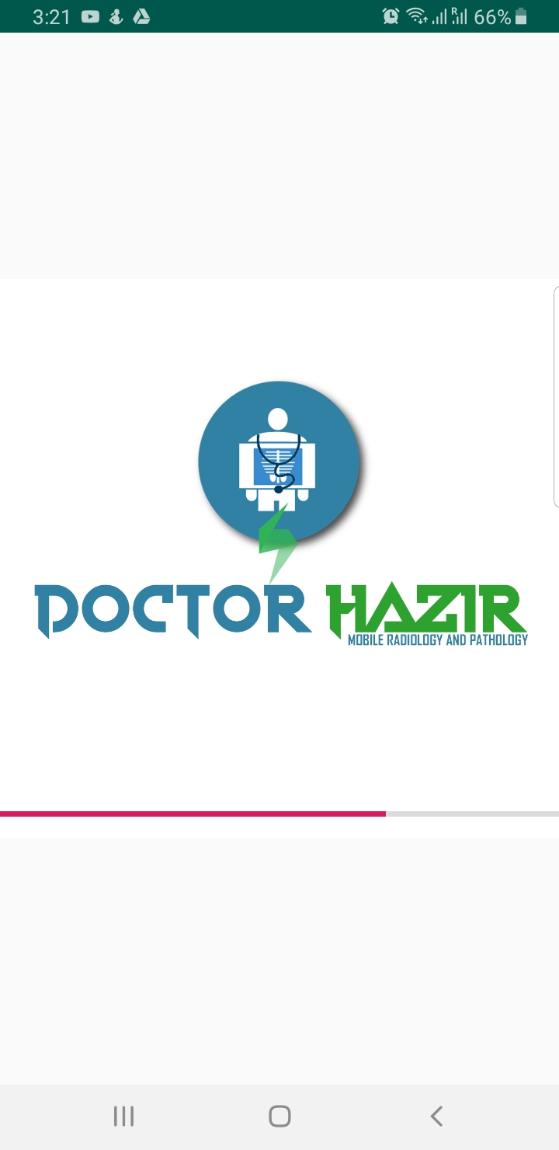

Figure 3.4 splash screen

* + 1. **Login Phase**

Login phase has following steps

1. User will provide his/her credentials in this phase.
2. If user is verified, then the home screen will open.

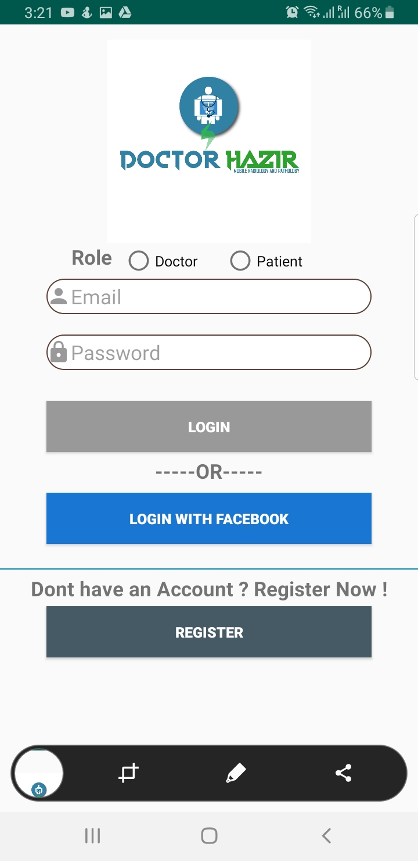

**Figure 3.5** login phase

* + 1. **Registration Phase**

Registration Phase has following steps.

1. User must provide his credentials to register an account.
2. The details will be stored on the cloud.

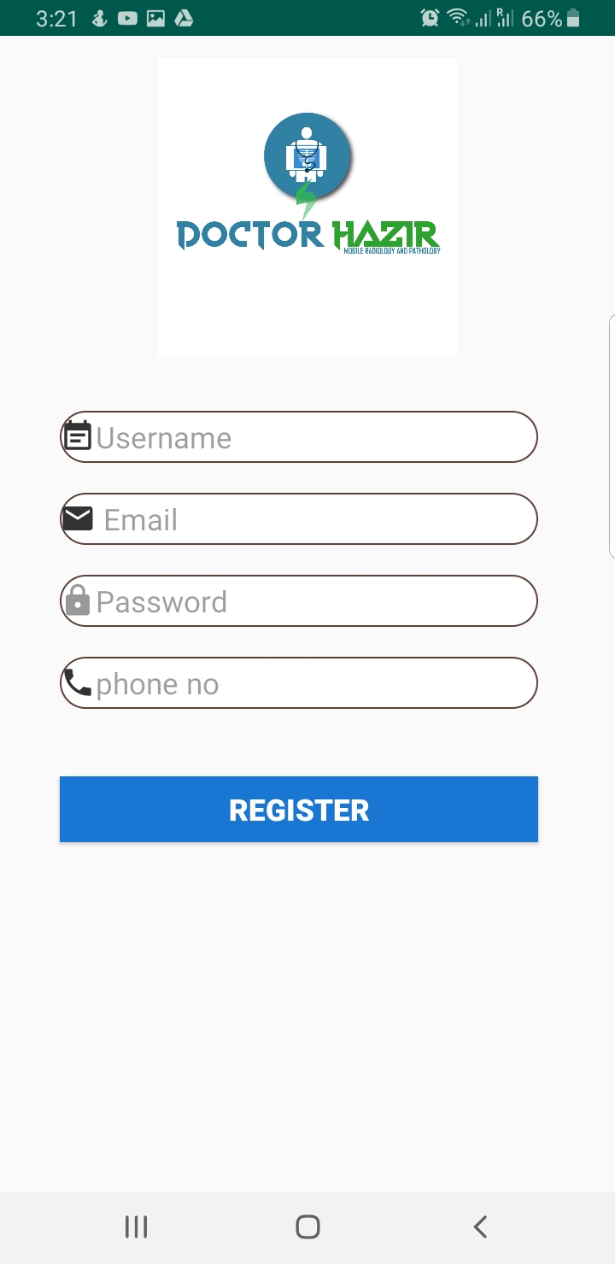

**Figure 3.6 Registration Phase**

* + 1. **Doctor’s Home Screen**

Doctor’s home screen has following options.

1. Doctor can check the scanned cases.
2. Doctor can check uploaded reports.
3. Doctor can check all the posts from patients.
4. Doctor can also add post about anything.

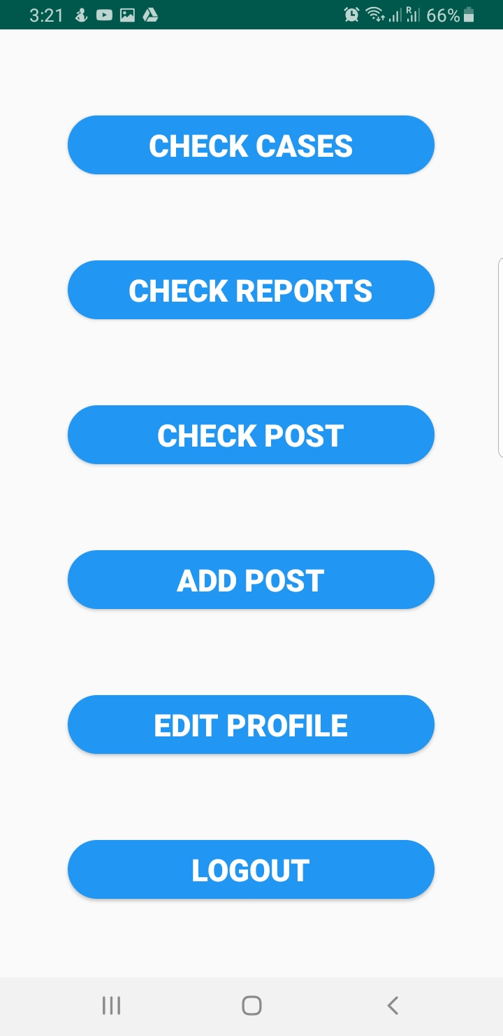

## 

# Figure 3.7 Doctors home screen

## REFERENCES

[1] Lippman H. How apps are changing family medicine. J Fam Pract. 2013; 62:3627

[PubMed] [Google Scholar]

[2] Park S, Parwani A, Satyanarayanan M, Pantanowitz L. Handheld computing in pathology. J Pathol Inform. 2012; 3:15. [PMC free article] [PubMed] [Google Scholar]

[3] Lehman JS, Gibson LE. Smart tele dermatopathology: A feasibility study of novel, high-value, portable, widely accessible and intuitive telepathology methods using handheld electronic devices. J Cutan Pathol. 2013; 40:513–8. [PubMed] [Google Scholar]

[4] Morrison AS, Gardner JM. Smart phone microscopic photography. A novel tool for physicians and trainees. Arch Path Lab Med. 2013. [PubMed] [Google Scholar]

[5] T. Gillespy, Optimized Algorithms for Displaying 16-bit Gray Scale

Images on 8-bit Computer Graphic Systems, Journal of Digital Imaging, Vol. 6, No. 1, 1993, pp. 25-29

[6] Digital Imaging and Communications in Medicine (DICOM), NEMA

Publications, DICOM Part 18: Web Access to DICOM Persistent Objects (WADO), 2009

[7] A.E. Flanders, R.H. Wiggins III, M.E. Gozum, Handheld Computers in

Radiology, RadioGraphics 2003; 23:1035-1047 Published online 10.1148/rg.234035011(2003)

[8] M. Trevino, Personal digital assistants fail to catch on with busy radiologists. Diagnostic Imaging, September 2002. September 30, 2002.

[9] Romero Lauro G, Cable W, Lesniak A, Tseytlin E, McHugh J, Parwani A, et al. Digital pathology consultations-a new era in digital imaging, challenges and practical applications. J Digit Imaging. 2013; 26:668–77. [[PMC free article](https://www.ncbi.nlm.nih.gov/pmc/articles/PMC3705002/)] [[PubMed](https://www.ncbi.nlm.nih.gov/pubmed/23359091)] [[Google Scholar](https://scholar.google.com/scholar_lookup?journal=J+Digit+Imaging&title=Digital+pathology+consultations-a+new+era+in+digital+imaging,+challenges+and+practical+applications&author=Lauro+G+Romero&author=W+Cable&author=A+Lesniak&author=E+Tseytlin&author=J+McHugh&volume=26&publication_year=2013&pages=668-77&pmid=23359091&)]

[10] Avram A. Facebook: ‘Betting on HTML5 was a mistake’- Technical Reasons and reactions. Infoq.com Sept 17. 2012. [Last cited on 2013 Nov 19]. Available from: <http://www.infoq.com/news/2012/09/Facebook-HTML5-Native> .

[11]  Dano M. LinkedIn Replaces HTML5-powered Search with Native Code on iPad App. FierceMobileIT.com Nov 8. 2012. [Last cited on 2013 Nov 19]. Available from: <http://www.fiercemobileit.com/story/linkedin-replaces-html5-powered-search-native-code-ipad-app/2012-11-08> .

[12] Stoecker WV, Rader RK, Halpern A. Diagnostic inaccuracy of smartphone applications for melanoma detection: Representative lesion sets and the role for adjunctive technologies. JAMA Dermatol. 2013; 149:884. [[PubMed](https://www.ncbi.nlm.nih.gov/pubmed/23864094)] [[Google Scholar](https://scholar.google.com/scholar_lookup?journal=JAMA+Dermatol&title=Diagnostic+inaccuracy+of+smartphone+applications+for+melanoma+detection:+Representative+lesion+sets+and+the+role+for+adjunctive+technologies&author=WV+Stoecker&author=RK+Rader&author=A+Halpern&volume=149&publication_year=2013&pages=884&pmid=23864094&)]

[13] van Velsen L, Beaujean DJ, van Gemert-Pijnen JE. Why mobile health app overload drives us crazy, and how to restore the sanity. BMC Med Inform Decis Mak. 2013;13:23. [[PMC free article](https://www.ncbi.nlm.nih.gov/pmc/articles/PMC3621678/)][[PubMed](https://www.ncbi.nlm.nih.gov/pubmed/23399513)] [[Google Scholar](https://scholar.google.com/scholar_lookup?journal=BMC+Med+Inform+Decis+Mak&title=Why+mobile+health+app+overload+drives+us+crazy,+and+how+to+restore+the+sanity&author=L+van+Velsen&author=DJ+Beaujean&author=JE+van+Gemert-Pijnen&volume=13&publication_year=2013&pages=23&pmid=23399513&)]

[14] Al-Jumeily, H. Tawfik, A. H. Mohamed and L. Norton, "MoHTAM: A Technology Acceptance Model for Mobile Health Applications," *2011 Developments in E-Systems Engineering (DESE)*

[15] A. Mumtaz, S. Keyani, Q. Babar and H. Qureshi, "Monitoring Disease Outbreak through Geographical Representation in Rural Areas," *2011 Developments in E-systems Engineering (DESE)*

[16] Digital Imaging and Communications in Medicine (DICOM), NEMA Publications, DICOM Part 18: Web Access to DICOM Persistent Objects (WADO), 2009

[17] A.E. Flanders, R.H. Wiggins III, M.E. Gozum, Handheld Computers in Radiology, RadioGraphics 2003; 23:1035-1047 Published online 10.1148/rg.234035011(2003)

[18] M. Trevino, Personal digital assistants fail to catch on with busy radiologists. Diagnostic Imaging, September 2002. September 30, 2002.

[19] P. Georgiadis et al., PDA-based system with teleradiology and image analysis capabilities, Proceedings of 29th Annual International Conference of the IEEE EMBS, Lyon, France, August 23-26, 2007

[20] W. Bonn, A. Flanders, Survey of Personal Digital Assistant Use in Radiology”, RadioGraphics 2005

[21] N. Nakata, S. Kandatsu, N. Suzuki, K. Fukuda, Informatics in Radiology (infoRAD): mobile wireless DICOM server system and PDA with highresolution display: feasibility of group work for radiologists, Radiographics, vol. 25, pp. 273-283, Jan-Feb 2005

## APPENDICES

APPENDIX A: Gantt Chart

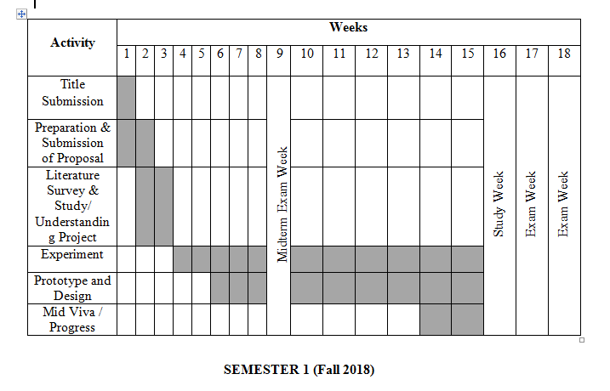

**Spring 2019**

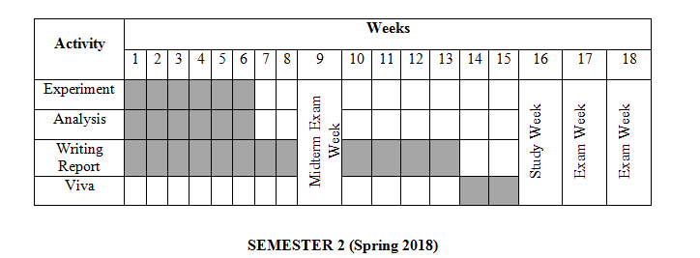

**Fall 2019**